**Experiment-3**

**Jenkins Integration with GitHub and Maven**

**Step-1:** Open Command line and type the command to run the Jenkins.

**“java -jar Jenkins.war”**

Type localhost:8080 in the browser to run the Jenkins and login.

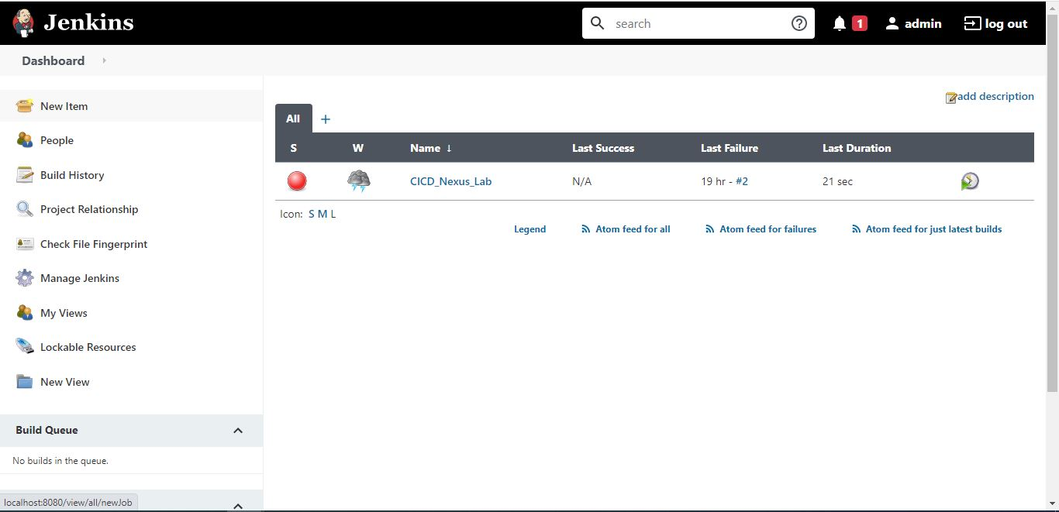

**Step-2:** Click on the new item to create a new maven project and specify the name and click ok.

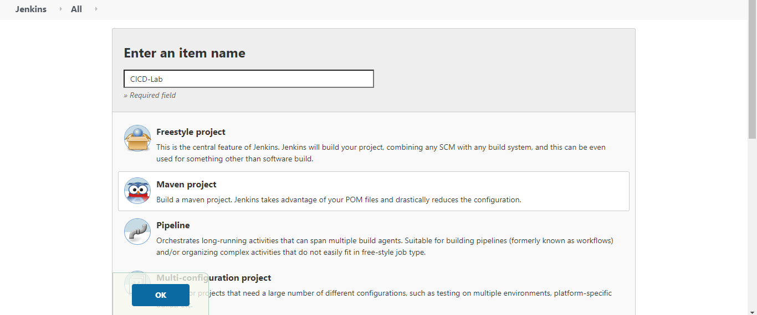

**Step-3:** Now make further settings. Go to source code management, click on git, and provide the URL of the GitHub repository and path of pom.xml file.

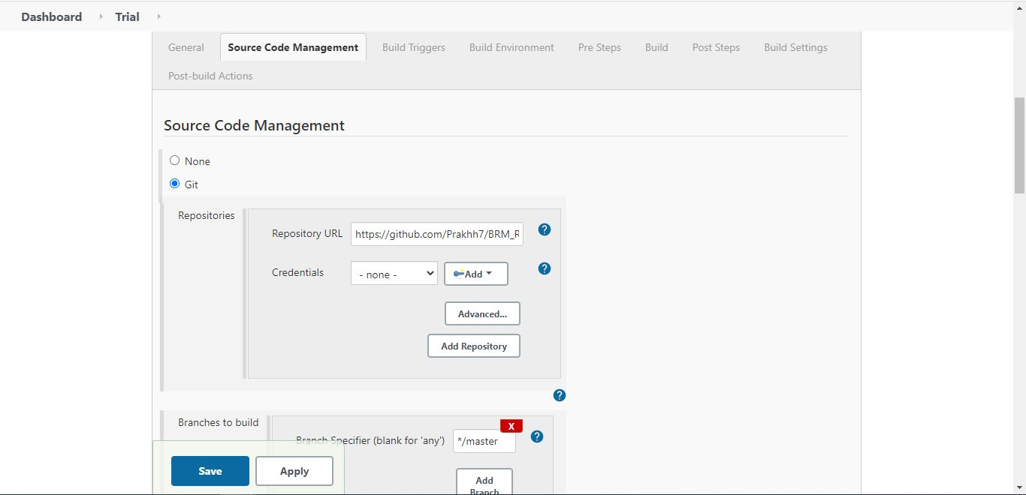

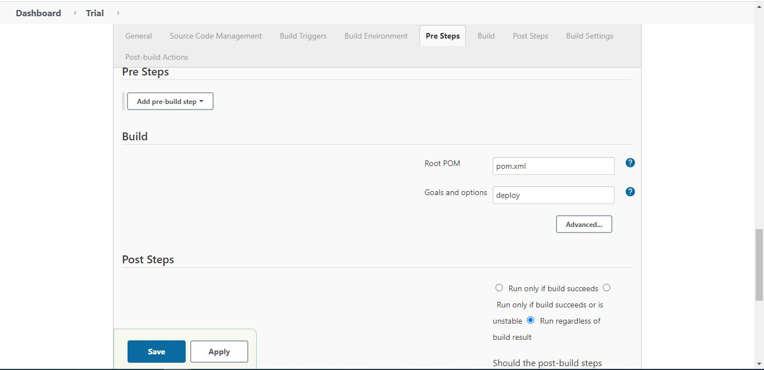

**Step-4:** Click on save button and your Jenkins is integrated with GitHub and maven for this repository. Click on Build now to check the code and the changes you made.

